ELEC97094/ELEC97095 Wireless Communications

Coursework 1: Link-level Performance

Evaluation of SISO/SIMO/MISO

Zhaolin Wang

1. **QPSK Modulation**

In this coursework, the QPSK modulation with Gray coding is used. The constellation is shown below.

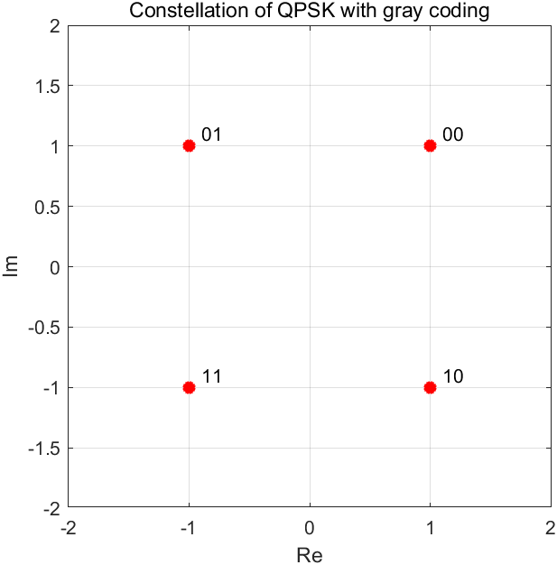

Fig 1. Constellation of QPSK (Gray coding)

For adjacent symbols in this constellation, there is only one different bit, therefore the relationship between the symbol error rate $P_{s}$ and the bit error rate (BER) $P_{e}$ is

|  |  |  |
| --- | --- | --- |
|  | $$P_{e}=\frac{P_{s}}{2}$$ | (1) |

1. **SISO Rayleigh Fading Channel**

For the SISO Rayleigh fading channel, the received signal model is

|  |  |  |
| --- | --- | --- |
|  | $$y=\sqrt{E_{s}}hc+n$$ | (2) |

where $E_{s}$ is the symbol power, $h\sim \text{CN}(0,1)$ is the Rayleigh channel gain, $c$ is the communication symbol, and $n\sim \text{CN}(0,σ_{n}^{2})$ is the cyclic symmetry Gaussian noise.

The coherent detection is used at the receiver.

|  |  |  |
| --- | --- | --- |
|  |  | (3) |

According to the property of cyclic symmetry Gaussian variable, $h^{*}n\sim \text{CN}(0,σ_{n}^{2})$. For any constellation, the probability of the symbol error is

|  |  |  |
| --- | --- | --- |
|  |  |  |
|  |  | (4) |

where ${\overline{N}}_{e}$ is the number of nearest neighbors, $d_{min}$ is the minimum distance of the separation of the normalized constellation, $ρ=\frac{E_{s}}{σ_{n}^{2}}$ is the SNR, and $s^{2}={\left|h\right|}^{2}$ is the random variable. The PDF of the variable $u=s^{2}$ is

|  |  |  |
| --- | --- | --- |
|  | $$p_{u}\left(u\right)=\frac{1}{2σ^{2}}exp⁡(-\frac{u}{2σ^{2}})$$ | (5) |

where $σ^{2}=1/2$ in this case. Therefore, the probability of symbol error can be written as

|  |  |  |
| --- | --- | --- |
|  | $$P_{s}={\overline{N}}_{e}\int_{0}^{∞}{\text{Q}\left(d_{min}\sqrt{\frac{ρu}{2}}\right)}p_{u}\left(u\right)du={\overline{N}}_{e}\int_{0}^{∞}{\text{Q}\left(d_{min}\sqrt{\frac{ρu}{2}}\right)}exp⁡(-u)du$$ | (6) |

For the QPSK used in this course work, ${\overline{N}}_{e}=2$ and $d_{min}=\sqrt{2}$. According to (1), the theoretical BER for SISO is

|  |  |  |
| --- | --- | --- |
|  | $$P_{e, SISO}={\frac{1}{2}\overline{N}}_{e}\int_{0}^{∞}{\text{Q}\left(d_{min}\sqrt{\frac{ρu}{2}}\right)}exp⁡(-u)du$$ | (7) |

Fig 2 shows the simulation result and theoretical result in SISO case, which indicate the simulation result is inline with the theory.

1. **SIMO i.i.d. Rayleigh Fading Channel with MRC**

For the SIMO i.i.d. Rayleigh fading channel with $N$ received antennas, the received signal model is

|  |  |  |
| --- | --- | --- |
|  | $$y=\sqrt{E_{s}}hc+n$$ | (8) |

where $y={\left[y_{1},⋯,y_{N}\right]}^{T}$, $h={\left[h_{1},⋯,h_{N}\right]}^{T}$ and $n={\left[n_{1},⋯,n_{N}\right]}^{T}$.

By using the maximum ratio combining (MRC),

|  |  |  |
| --- | --- | --- |
|  |  | (9) |

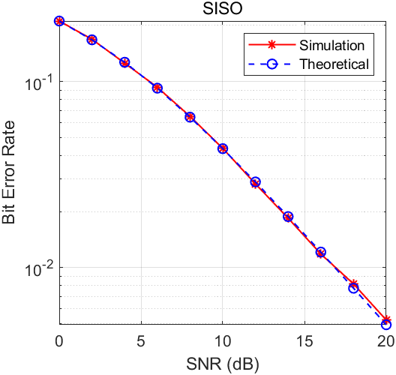

Fig 2. Simulation and theoretical result of BER in SISO case

Similarly, the BER can be written as

|  |  |  |
| --- | --- | --- |
|  | $$P_{e, SIMO(MRC)}={\frac{1}{2}\overline{N}}_{e}\int_{0}^{∞}{\text{Q}\left(d_{min}\sqrt{\frac{ρt}{2}}\right)}p_{t}\left(t\right)dt$$ | (10) |

where ${t=\left\|h\right\|}^{2}$ has the distribution of

|  |  |  |
| --- | --- | --- |
|  | $$p_{t}\left(t\right)=\frac{1}{\left(N-1\right)!}t^{N-1}e^{-t}$$ | (11) |

Fig 3 shows the simulation result and theoretical result in SIMO case with MRC, which indicate the simulation result is inline with the theory.

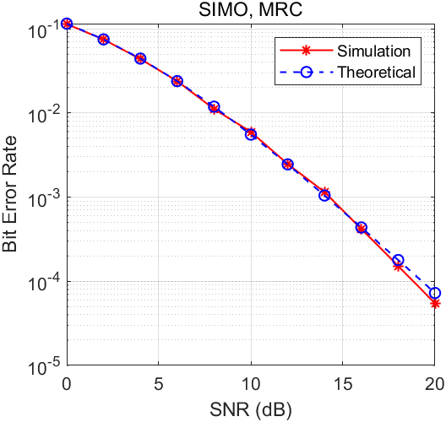

Fig 3. Simulation and theoretical result of BER in SIMO case with MRC

1. **MISO i.i.d. Rayleigh Fading Channel with MRT**

For the MISO i.i.d. Rayleigh fading channel with $N$ transmitted antennas, the received signal model is

|  |  |  |
| --- | --- | --- |
|  | $$y=\sqrt{E_{s}}hwc+n$$ | (12) |

where $w={h^{H}}/{\left\|h\right\|}$ is the maximum ratio transmission (MRT) matrix. The BER in this case is the same as the one in SIMO case with MRC, therefore we have

|  |  |  |
| --- | --- | --- |
|  | $$P_{e, MISO(MRT)}={\frac{1}{2}\overline{N}}_{e}\int_{0}^{∞}{\text{Q}\left(d_{min}\sqrt{\frac{ρt}{2}}\right)}p_{t}\left(t\right)dt$$ | (13) |

Fig 4 shows the simulation result and theoretical result in MISO case with MRT, which indicate the simulation result is inline with the theory.

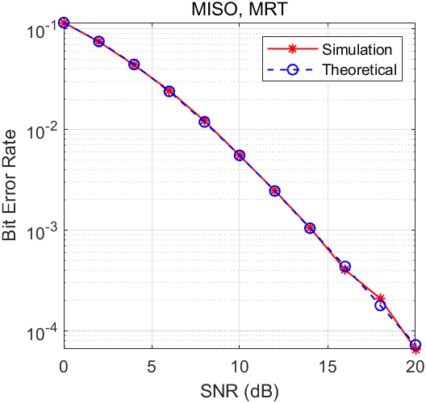

Fig 4. Simulation and theoretical result of BER in MISO case with MRT

1. **MISO i.i.d. Rayleigh Fading Channel with Alamouti scheme**

For the Alamouti scheme, the received signal model over two antennas and over two symbol periods can be written as

|  |  |  |
| --- | --- | --- |
|  | $$y=\left[\begin{matrix}y_{1} \\ y_{2}^{*}\end{matrix}\right]=\sqrt{E_{s}}H_{eff}c+n$$ | (14) |

where $H_{eff}=\left[\begin{matrix}h_{1} & h_{2} \\ h_{2}^{*} & -h_{1}^{*}\end{matrix}\right]$, $c=\left[\begin{matrix}{c_{1}}/{\sqrt{2}} \\ {c_{2}}/{\sqrt{2}}\end{matrix}\right]$, and $n=\left[\begin{matrix}n_{1} \\ n_{2}^{*}\end{matrix}\right]$. The matched filter ${H_{eff}}^{H}$ is used to receive the symbols, which is shown below

|  |  |  |
| --- | --- | --- |
|  |  | (15) |

By observing the equation (15), the single received symbol can be written as

|  |  |  |
| --- | --- | --- |
|  |  | (16) |

In this case, the BER is

|  |  |  |
| --- | --- | --- |
|  | $$P_{e, MISO(Alamouti)}={\frac{1}{2}\overline{N}}_{e}\int_{0}^{∞}{\text{Q}\left(d_{min}\sqrt{\frac{ρt}{4}}\right)}p_{t}\left(t\right)dt$$ | (17) |

where $p_{t}\left(t\right)$ is the same as equation (11).

Fig 5 shows the simulation result and theoretical result in MISO case with Alamouti scheme, which indicate the simulation result is inline with the theory.

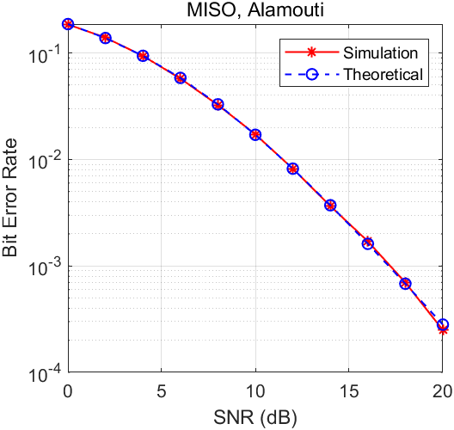

Fig 5. Simulation and theoretical result of BER in MISO case with Alamouti scheme

1. **Comparison Analysis**

Fig 6 shows the comparison of simulation results in the four cases above. In the SISO case, there is no diversity exploited, leading the worst performance in terms of BER. In other three cases, the diversity is exploited to achieve the diversity gain, leading to the better performance than SISO case. Apart from the diversity gain, both SIMO with MRC and MISO with MRT also achieves the array gain, which makes them have better performance that MISO with Alamouti scheme.

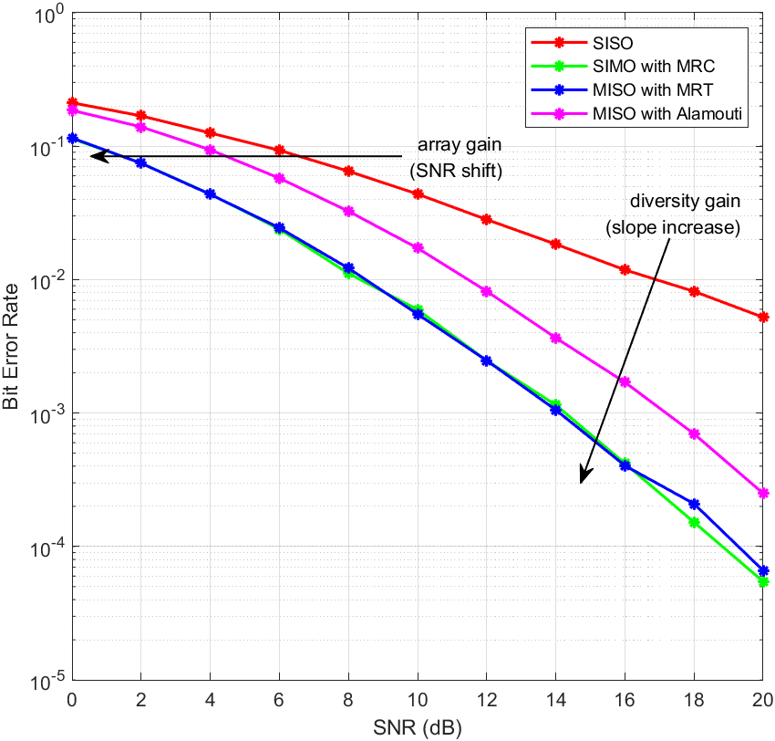

Fig 6. Comparison of the simulation results in the case of SISO, SIMO with MRC, MISO with MRT, and MISO with Alamouti scheme

However, there is no need of channel state estimation at transmitter (CSIT) for the MISO with Alamouti scheme.

By the definition of diversity gain, which is

|  |  |  |
| --- | --- | --- |
|  | $$g_{d}^{o}\left(ρ\right)≜-\frac{\log_{2}\left(P_{e}\right)}{\log_{2}\left(ρ\right)}, ρ→∞$$ | (18) |

the diversity gain is indicated by the slope increase at high SNR in Fig 6. For the SISO case, there is no diversity so its diversity gain is 1, while for other three cases, there are 2 antennas in this coursework so their diversity gains are 2. Therefore, the curves of SIMO and MISO cases have the same slope at high SNR in Fig 6.

According to the definition of array gain, which is

|  |  |  |
| --- | --- | --- |
|  | $$g_{a}≜\frac{{\overline{ρ}}_{out}}{ρ}$$ | (19) |

the array gain is indicated by the SNR shift in Fig 6. The SIMO with MRC and MISO with MRT has the same array gain, meanwhile they also have the same diversity gain. Therefore, the curves of them are almost the same. While for the MISO with Alamouti scheme, there is no array gain because of the lack of transmit channel knowledge, which makes its curve shift right compare with the curves of SIMO with MRC and MISO with MRT.